Official 2022
“We Appreciate Teachers” Contest
Information and Application
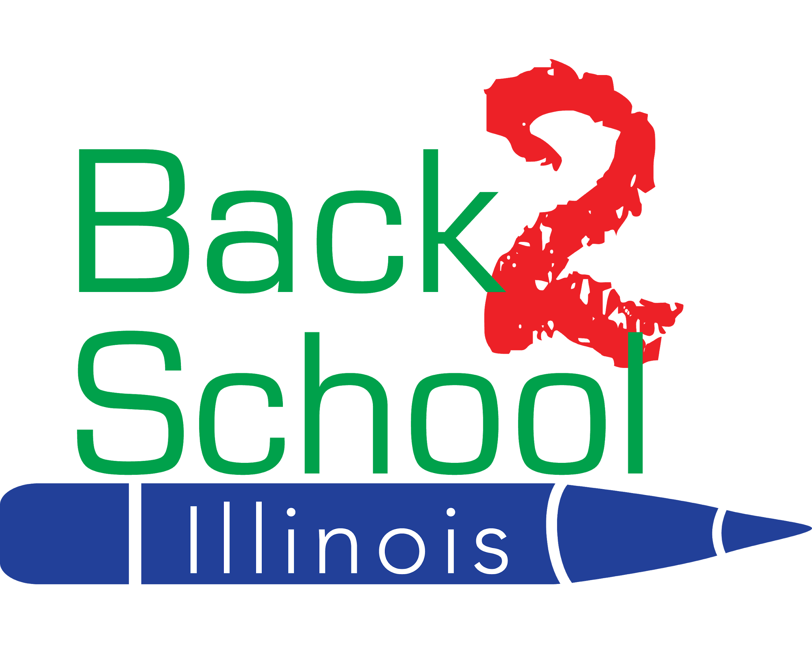
1946 W. Irving Park Road
Chicago, IL 60613
www.B2SI.org

Contest Guidelines

Back 2 School Illinois (B2SI) believes education is the key to America’s future This contest is designed to draw attention to the hard work of teachers and what an important role they play in our society and the ways they impact our children.

What is the mission of Back 2 School Illinois (B2SI)?
The mission of Back 2 School Illinois is to create and support educational opportunities that enrich the lives of Illinois children.
What will the winning teachers receive?
Fifteen teachers will be awarded 30 Back 2 School Illinois kits for their classroom, plus a gift basket for themselves.

Who Can Apply?
Anyone can submit an application on behalf of a teacher, including the teacher himself/herself. The teacher must be currently employed by a school in Illinois.

Who is not eligible?
B2SI Board member employees and/or contracted workers for the nonprofit, and anyone living in their households including spouses, children or grandparents are not eligible to win nor submit an application on behalf of a teacher.

What's the Process?
- Complete the entire application one of two ways:
  - Print and fill out the application, attach your essay, and mail it to our office.
  - Fill out and submit the online application, available at https://forms.gle/sLd9AmS9ZMvLFZmW9
- Applications must be received no later than April 1, 2022.
- Winning teachers will be selected by the Education Director and the B2SI selection committee.
- Only the winning teachers will be notified by email or phone.

If sending application via mail, please address to:

“We Appreciate Teachers Contest”
Back 2 School Illinois
1946 W. Irving Park Road
Chicago, IL 60613

Application checklist: The following is a list of guidelines to help ensure that you have completed the entire application process.
- Fill out the entire application form. Make sure you include an essay describing why this teacher deserves the nomination!
- Submit your application online or mail your completed application to our B2SI office.
- Applications must be received by April 1, 2022 to be considered. Incomplete applications will not be considered.
- Recipients will be notified by April 11, 2022.

B2SI “We Appreciate Teachers” Contest
Application

Your Name
First Last

Street Address Apt.

City State Zip Code

Cell Phone # Home/Work Phone #

E-mail address

Name of Teacher Nominated

School where Teacher is Employed and Street Address

City__________________________________State_________________ Zip Code__________________

Teacher Telephone #

Teacher Email Address

What is your affiliation/relationship with the teacher?

Is there any additional information that we should know about the teacher you have nominated? (e.g. Awards, volunteer work, membership in community organizations)

_____________________________________________________________________________________________

_____________________________________________________________________________________________

“WHY DOES THIS TEACHER DESERVE TO WIN?”
250-500 words (on separate sheet): Please type or print on a separate sheet of paper.

